Enterprise Spatial Data Management

SIM Behavioral Specification

Document Version: 0.2

Document ID: SIM Behavioral Spec

Date: 07 Mar 201623 December 2015

|  |  |  |  |
| --- | --- | --- | --- |
| Signature: |  | Date: |  |
|  | Sharon McGowan, DTP Program Manager | | |
|  |  |  |  |
| Signature: |  | Date: |  |
|  | Don Smith, MDA Aviation Program Manager | | |
|  |  |  |  |
| Signature: |  | Date: |  |
|  | Tim Scheuer, ESDM Phase 1 Project Manager | | |
|  |  |  |  |
| Signature: |  | Date: |  |
|  | Tom Lonski, Jeppesen Voyager Chief Engineer | | |
|  |  |  |  |
| Signature: |  | Date: |  |
|  | Michael Lingren, MDA Aviation Chief Engineer | | |
|  |  |  |  |
| Signature: |  | Date: |  |
|  | Mark Tortington, Richmond Quality Assurance | | |

Document Revision History

|  |  |  |  |
| --- | --- | --- | --- |
| Date | Version | Description of Changes | Author(s) |
| 23 Dec 2015 | 0/1 | Initial Draft | Scott Galbraith |
| 07 Mar 2016 | 0.2 | Changed State Time to Total Run Time and updated effected behaviors | Scott Galbraith |
| 31 Mar 2016 | 0.3 | Updated valid file type extensions and added exit behaviors | Scott Galbraith |
|  |  |  |  |
|  |  |  |  |
|  |  |  |  |
|  |  |  |  |
|  |  |  |  |
|  |  |  |  |
|  |  |  |  |
|  |  |  |  |

Document Authors

|  |  |
| --- | --- |
| Name | Title |
| Scott Galbraith | UXD Engineer |
| Chad Swierczek | Requirements Analyst |
|  |  |
|  |  |

Document Approval History

|  |  |  |
| --- | --- | --- |
| Date | Version | Approvers |
|  |  |  |

Table of Contents

1 Introduction 5

1.1 Purpose 5

1.2 Scope 5

1.3 Overview 5

1.4 Stakeholder Requirements List 6

1.4.1 Applicable Themes 6

1.4.2 Applicable Epics 6

1.5 Issues 6

2 Documents 7

2.1 Referenced Documents 7

3 Load Source 8

3.1 Overview 8

3.2 Load Source UI Elements and Associated Behaviors 8

4 State Manager (#27 from Load Source) 17

4.1 Overview 17

4.2 State Manager UI Elements and Associated Behaviors 17

5 State Manager Job Details 24

5.1 Overview 24

5.2 Job Details UI Elements and Associated Behaviors 24

5.3 Compare State UI Elements and Associated Behaviors 26

5.4 Transform State UI Elements and Associated Behaviors 28

5.5 Archive State UI Elements and Associated Behaviors 29

5.5.1 Business Rules 30

5.5.2 Supplemental Requirements 30

5.6 Dependencies 30

6 Future Requirements – Post R1 31

6.1 Overview 31

6.2 Applicable Sub-Epics 31

6.2.1 Unstructured Source – SRL Feature ID# 31

6.2.2 Create BPM - SRL Feature ID# 31

6.2.3 UI for ESL/Documentum - SRL Feature ID# 31

6.2.4 31

7 Appendix A – Provider to Source Table 32

List of Tables

Table 1‑1 Outstanding Issues 6

# Introduction

## Purpose

To document the User Interface (UI) Behavioral Requirements and User Experience Design (UXD) definition for the Source Information Management System (SIM) Source Upload and associated State Manager functionality within the ESDM System.

## Scope

This document only addresses the UI Behavioral Requirements and UXD for the SIM Source Upload and associated State Manager functionality within the ESDM System for Release 1 Obstacles.

## Overview

The SIM subsystem of the ESDM application is comprised of two main components. The first is the Source Upload functionality with its associated metadata and details panels. The second is the State Manager where all source files are tracked as SIM Jobs through each state of the ingest process. These two main components break down into the following functionalities:

|  |  |  |
| --- | --- | --- |
| Component | Description | In scope for Release 1 (Y/N) |
| Upload Source | Provides the ability to select new source file and fill associated metadata fields. | Yes |
| Compare Source | Allows analyst to compare new source to previous source. | Yes |
| Create New SIM Job | Gives the analyst the ability to view progress of running jobs as well as receive detailed status of any failures. | Yes |
| Manage SIM Jobs | Gives the analyst thee ability to stop, edit and start jobs | Yes |
| SIM Job Filters | Provide filtering on records available for quick access to specific record(s) | Yes |
| SIM Job Delete | Ability to remove and rollback database changes to avoid orphan data in database | Yes |

## Stakeholder Requirements List

The Stakeholder Requirements List (SRL) defines the Business capabilities that the ESDM System is expected to provide or enhance. This list has been created, prioritized and managed by the Business and drives the plan and schedule for the implementation of the ESDM System. For the sake of traceability the SRL capabilities that are relevant to this document have been identified.

### Applicable Themes

#### Source Information Management (?)

### Applicable Epics

#### (???)

## Issues

Table 1‑1 is used to capture and communicate outstanding issues.

Table 1‑1 Outstanding Issues

|  |  |  |  |
| --- | --- | --- | --- |
| No. | Date | Status | Issue |
| 1 | Dec 23, 2015 | Open | RISK: Reference data availability for selected Provider and Source Type to provide metadata values carried downstream |
| 2 | Dec 23, 2015 | Open | RISK: Hand-off communication notifying NIM of new source availability. |
|  |  |  |  |

# Documents

## Referenced Documents

List of documents referenced by this document. See the particular reference for the applicable reference context.

|  |  |  |
| --- | --- | --- |
| Reference # | Document Id | Title and Version |
| [User Interface Style Guide] | GNTS_ESDM_UIStyleGuide_v10.docx | GNTS_ESDM_UIStyleGuide_v10.docx |
| SIMProviderFormatTable | SimProviderFormatTable_V4_Dec21_aprvd_JZS.xlsx | SimProviderFormatTable_V4_Dec21_aprvd_JZS.xlsx |
|  |  |  |
|  |  |  |
|  |  |  |

# Load Source

## Overview

SIM provides the ability for the analyst to select a source file to upload into the SIM system for processing and transformation into a universal format for later use by the Navigation Information Management (NIM) and Product Creation & Distribution (PCD) subsystems. The first step required is to identify the source file and enter the associated metadata (Figure 1).

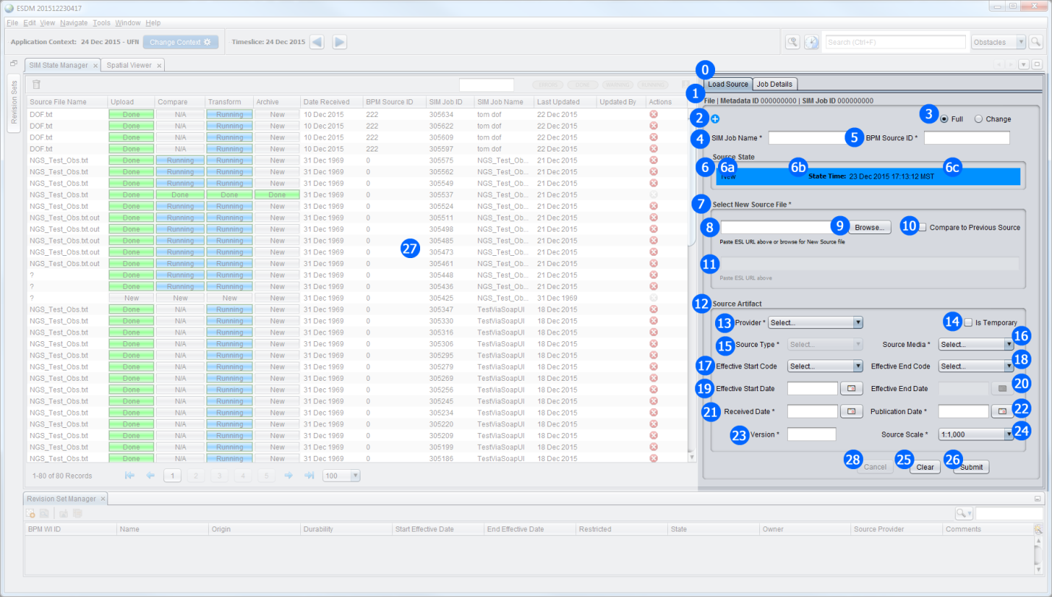

Figure 1

## Load Source UI Elements and Associated Behaviors

1. **Load Source Panel** – Provides the functionality to Upload New Source file with associated metadata, create new SIM Job, Edit existing source metadata, and view source file parameters with associated metadata for currently selected SIM Job. Will update as user interacts within or with State Manager data table.
   1. **Minimum Panel Size** **–** Width 600 x Height 710
   2. **Scrolling** – on lower resolution screens the panel will provide necessary scrollbar(s) for access to full panel
2. **Traceable Source Identification** – Located in the BorderTitle (HTML formatted) of the Upload Source Metadata panel; provides source and system level unique identifiers
   1. **File** – Read Only, bold label, plain value
      1. value is populated once ***Select New Source File*** field is populated
      2. value updates if ***Select New Source File*** field is updated
   2. **Metadata ID** – Read Only, bold label, plain value
      1. System generated ID value is populated as part of ***Add New Source*** action
      2. Value remains for life of SIM Job
   3. **SIM Job ID** – Read Only, bold label, plain value
      1. System generated ID value is populated as part of ***Add New Source*** action
      2. Value remains for life of SIM Job
3. **Add New Source** button – initiates the creation of new ID numbers and sets all UI elements on Load Source panel to default states and/or values
   1. **Help** Balloon text “Add New Source“
   2. **Form Default Values**:
      1. **File** – null
      2. **Metadata ID** – system generated unique number
      3. **SIM Job ID** – system generated unique number
      4. **Full** – radio button [selected]
      5. **SIM Job Name** – null
      6. **BPM Source ID** – null
      7. **Source State** – ‘New’
      8. **Total Run Time** – null value
      9. **Select New Source File** – null
      10. **Compare to Previous Source** – [unchecked]
      11. **Compare to Previous Source URL field** – disabled, null
      12. **Provider** – ‘Select…’
      13. **Is Temporary** – [unchecked]
      14. **Source Type** – disabled, displays ‘Select…’
      15. **Source Media** – ‘Select…’
      16. **Effective Start Code** – ‘Select…’
      17. **Effective End Code** – disabled, displays ‘Select…’
      18. **Effective Start Date** – null
      19. **Effective End Date** – disabled, displays null
      20. **Received Date** – null
      21. **Publication Date** – null
      22. **Version** – null
      23. **Source Scale** – 1:1,000
      24. **Clear button** – disabled
      25. **Submit button** – disabled
      26. **Enter** keyboard function- disabled
4. **Full/Change radio buttons** – defaults to ‘Full’ [selected]
   1. **Help Balloons Text**:
      1. Hovering over ‘Full’ displays “Source File is a Full File”
      2. Hovering over ‘Change’ displays “Source File is a Change File”
   2. If **Change** is selected, the following fields become disabled:
      1. **Compare to Previous Source** – [unchecked]
      2. **Compare to Previous Source URL** [default value null]
   3. If **Full** is selected, the following fields become enabled:
      1. **Compare to Previous Source** – [unchecked]
5. **SIM Job Name** text field – *Required
   1. **Help Balloon Text:** “An identifying name for the SIM Job which will be created for this source”
   2. **Default Field Value**: null
   3. Analyst provided value
   4. no restriction on character type or length
   5. **Validation 1:** Cannot be null
6. **BPM Source ID** – *Required
   1. **Help** Balloon text “Enter the BPM Work Item ID“
   2. **Default Field Value**: null
   3. Analyst provided value
   4. no restriction on character type or length
   5. **Validation 1:** Cannot be null
   6. **Validation 2**: value must be numeric (only allow numeric)
7. **Source State** – Read Only BorderTitle, HTML Formatted, System generated values
   1. **List of Values**:
      1. **New** [Background: FAA Cyan Shade 1 (0,145,255)] – displayed for new source upload before SIM Job submitted
      2. **Submitted** [Background: FAA Cyan Shade 1 (0,145,255)] – displayed at the point which user clicks the Submit button and before processing has started
      3. **Running** [Background: FAA Cyan Shade 1 (0,145,255)] – displayed after SIM Job submitted and processing has started
      4. **Stopped** [Background: FAA Red Shade 2 (200,0,0)] – displayed when analyst has stopped a running job
      5. **Done** [Background: FAA Green Shade 1 (0,255,0)] – displayed when SIM Job has successfully completed current state
      6. **Error** [Background: FAA Red Shade 2 (200,0,0)] – displayed when current state has stopped due to error
      7. **Warning** [Background: FAA Amber Shade 1 (255,180,0)] – displayed when system encounters a warning condition but processing of SIM Job continues
      8. **Deleted** [Background: FAA Red Shade 3 (160,0,0)] – displayed when a SIM Job has been deleted
   2. **Total Run Time** – HH:MM:SS formatted total time for all States to complete
      1. If the SIM Job has begun **but not** completed this field will be blank
      2. If the SIM Job has completed, show the sum of processing time through all states
      3. If SIM Job is stopped, Total Run Time will reflect time the job ran until being stopped.
   3. **Status Message** – a temporary message displayed to the right of **Total Run Time** indicating success, error, etc.
      1. **Timer Length:** 5 seconds, after which the message fades to zero visibility
      2. **List of Values**:
         1. **Success** [Foreground: FAA Green Shade 1 (0,255,0)]
         2. **Failure** [Foreground: FAA Red Shade 1 (255,0,0)]
8. **Select New Source File** – Read Only BorderTitle, HTML formatted
9. **Select New Source File** text field – *Required
   1. **Help** Balloon text “Choose the new Source file you want to load“
   2. **Default Field Value**: null
   3. Analyst provided value (type, paste, or Browse dialog)
   4. **Validation 1:** Must be valid location
      1. **Error message:** “Invalid Source File location”
   5. **Validation 2:** Must be valid file type
      1. **Error Message**: “Source file must be valid file type”
10. **Browse…** - button when pressed displays the standard desktop application file browse dialog with standard behaviors
    1. **Validation 1**: Only allow browsing of valid file types:
       1. Text (*.txt)
       2. Excel (*.xls, *.xlsx)
       3. CSV (*.csv)
       4. XML (*.xml)
       5. DAT (*.dat)
       6. CRC (*.crc)
    2. **Validation 2**: Disallow selecting of invalid file types
11. **Compare to Previous Source** checkbox
    1. **Help** Balloon text “Check if you want to compare to the Previous Source file“
    2. **Default Field Value**: [unchecked]
    3. If [checked] the following occurs:
       1. **Compare to Previous Source URL** field (#11) is enabled
    4. If [unchecked] the following occurs:
       1. **Compare to Previous Source URL** field (#11) is disabled [default value is null]
12. **Compare to Previous Source URL** text field
    1. **Help** Balloon text “Paste ESL URL of Previous Source“
    2. **Default Field Value**: null
    3. If **Compare to Previous Source** checkbox is [unchecked] this field becomes disabled and value returned to null
    4. **Validation 1:** if **Compare to Previous Source** checkbox is [checked] then this field is required
    5. **Validation 2:** Must be valid location
       1. **Error Message**: “Invalid Previous Source location”
    6. **Validation 3:** Must be valid file type
       1. **Error Message**: “Invalid file type specified”
13. **Source Artifact** – Read Only BorderTitle, HTML formatted
14. **Provider** combo box (type-ahead filter) – *Required
    1. **Help** Balloon text “Provider of this Source“
    2. **Default Field Value**: ‘Select…’
    3. **Type**-ahead filter is not case sensitive
    4. **List of Values**: {See Appendix A}
       1. Select…
       2. AIP_FINLAND
       3. AIP_LATVIA
       4. AIP_SPAIN
       5. AIP_SWITZERLAND
       6. AIP_TURKEY
       7. AIP_UK_CIVILIAN
       8. MISC
       9. UK_RAF_RESTRICTED
       10. USA_DVOF
       11. USA_FAA
       12. USA_NGS_ODS
    5. **Validation 1**: if **Provider** value changes, **Source Type** values must change to reflect only those Source Types available for the **Provider** selected (See Appendix A – Provider-to-Source table for values mapping)
    6. **Validation 2:** If **Full/Change** (#3) set to ‘Change’ then only Providers of Change source types will display in the List of Provider Values
    7. **Validation 3:** If **Full/Change** (#3) set to ‘Full’ only Providers of Full source types will display in the List of Provider Values
15. **Is Temporary** checkbox
    1. **Help** Balloon text “Check if Source has an Effective End Date or Effective End Code“
    2. **Default Field Value**: [unchecked]
    3. If [checked] the following occurs:
       1. **Effective End Code** field (#18) is enabled [default value displayed is ‘Select…’]
       2. **Effective End Date** field (#20) is enabled [default value is null]
    4. If [unchecked] the following occurs:
       1. **Effective End Code** field (#18) is disabled [default value displayed is ‘Select…’]
       2. **Effective End Date** field (#20) is disabled [default value is null]
16. **Source Type** combo box – *Required
    1. **Help** Balloon text “Source Type“
    2. **Default Field Value**: ‘Select…’
    3. Disabled until **Provider** selected
    4. **List of Values:**
       1. Select…
       2. DOF_CHANGE_DAT
       3. DOF_FULL_DAT
       4. DVOF_FULL_TXT
       5. eTOD_FNLND_CSV
       6. eTOD_LATVIA_XML
       7. eTOD_SPN_ARPT1_CSV
       8. eTOD_SPN_ARPT2_CSV
       9. eTOD_SPN_ENR_CSV
       10. eTOD_SWISS_XML
       11. eTOD_TURKARPT_EXCL
       12. eTOD_TURKENR_EXCL
       13. eTOD_UKCIVALL_EXCL
       14. NGS_ODS_TXT
       15. UK_RAF_RESTRICTED
       16. UNIV_SPEC_FILE
    5. **Validation 1:** If **Full/Change** (#3) set to ‘Change’ then Source Types of Full will not display in the List of Values
    6. **Validation 2:** If **Full/Change** (#3) set to ‘Full’ only source types of ‘Full’ will display in the List of Values
17. **Source Media** combo box - *Required
    1. **Help** Balloon text “Source Media Type“
    2. **Default Field Value**: ‘Select…’
    3. **List of Values**:
       1. Select…
       2. AFTN/NOTAM
       3. DVD
       4. Email
       5. Internet
       6. Mail
       7. Paper
       8. SFTP
18. **Effective Start Code** combo box –
    1. **Help** Balloon text “Effective Start Code“
    2. **Default Field Value**: ‘Select**…’**
    3. **List of Values:**
       1. Select…
       2. EBN
       3. WIE
19. **Effective End Code** combo box
    1. **Help** Balloon text “Effective End Code“
    2. **Default Field Value**: ‘Select…’
    3. **List of Values:**
       1. Select…
       2. EBN
       3. UFN
    4. **Validation 1:** If **Is Temporary** (#14) is [checked] **Effective End Code** is enabled and Default Field Value displays ‘Select…’
    5. **Validation 2**: If **Is Temporary** (#14) is [unchecked] **Effective End Code** is disabled and Default Field Value displays ‘Select…’
    6. **Validation 3**: If **Effective End Code** is enabled and value is not null **Effective End Date** (#20) is disabled and Default Field Value is null
    7. **Validation 4**: If **Effective End Code** is enabled and value is ‘Select…’ **Effective End Date** (#20)is enabled and Default Field Value is null
20. **Effective Start Date** calendar control
    1. **Help** Balloon text “Effective Start Date“
    2. **Default Field Value**: null
    3. **Date Format**: DD Mon YYYY
    4. **Validation 1: Effective Start Date** cannot be AFTER **Effective End Date**
21. **Effective End Date** calendar control
    1. **Help** Balloon text “Effective End Date“
    2. **Default Field Value**: null
    3. **Date Format**: DD Mon YYYY
    4. **Validation 1:** If **Is Temporary** (#14) is [checked] **Effective End Date** is enabled and Default Field Value is null
    5. **Validation 2**: If **Is Temporary** (#14) is [unchecked] **Effective End Date** is disabled and Default Field Value is null
    6. **Validation 3**: If **Effective End Date** is enabled and value is not null **Effective End Code** (#18) is disabled and Default Field Value displays ‘Select…’
    7. **Validation 4**: If **Effective End Date** is enabled and value is null **Effective End Code** (#18) is enabled and Default Field Value displays ‘Select…’
    8. **Validation 5**: **Effective End Date** cannot be BEFORE **Effective Start Date** (implemented as a disabling of all dates prior to selected **Effective Start Date**)
22. **Received Date** calendar control - *Required
    1. **Help** Balloon text “Received Date“
    2. **Default Field Value**: null
    3. **Date Format**: DD Mon YYYY
23. **Publication Date** calendar control - *Required
    1. **Help** Balloon text “Publication Date“
    2. **Default Field Value**: null
    3. **Date Format**: DD Mon YYYY
24. **Version** text field - *Required
    1. **Help** Balloon text “Version“
    2. **Default Field Value**: null
25. **Source Scale** combo box - *Required
    1. **Help** Balloon text “Source Scale“
    2. **Default Field Value**: ‘1:1,000’
    3. **List of Values**:
       1. 1:1,000
       2. 1:2,000
       3. 1:5,000
       4. 1:10,000
       5. 1:15,000
       6. 1:35,000
       7. 1:75,000
       8. 1:150,000
       9. 1:250,000
       10. 1:1,000,000
       11. 1:2,000,000
       12. 1:5,000,000
       13. 1:10,000,000
       14. 1:15,000,000
       15. 1:35,000,000
       16. 1:38,801,084
       17. 1:75,000,000
       18. 1:150,000,000
       19. 1:250,000,000
       20. 1:500,000,000
26. **Clear** button - sets all UI elements on Load Source panel to default states and/or values
    1. **Help** Balloon text “Clear all inputs“
    2. **Form Default Values**:
       1. **File** – null
       2. **Metadata ID** – system generated unique number
       3. **SIM Job ID** – system generated unique number
       4. **Full** – radio button [selected]
       5. **SIM Job Name** – null
       6. **BPM Source ID** – null
       7. **Source State** – ‘New’
       8. **Total Run Time** – null value
       9. **Select New Source File** – null
       10. **Compare to Previous Source** – [unchecked]
       11. **Compare to Previous Source URL field** – disabled
       12. **Provider** – ‘Select…’
       13. **Is Temporary** – [unchecked]
       14. **Source Type** – disabled, displays ‘Select…’
       15. **Source Media** – ‘Select…’
       16. **Effective Start Code** – ‘Select…’
       17. **Effective End Code** – disabled, displays ‘Select…’
       18. **Effective Start Date** – null
       19. **Effective End Date** – disabled, displays null
       20. **Received Date** – null
       21. **Publication Date** – null
       22. **Version** – null
       23. **Source Scale** – 1:1,000
       24. **Clear button** – disabled
       25. **Submit button** – disabled
       26. **Enter keyboard function**  (**Submit** button)- disabled
27. **Submit** button – default form action - disabled
    1. **Help** Balloon text “Submit Source and start SIM Job“
    2. The following conditions must be met to enable the **Submit** button:
       1. All required fields completed
    3. The following conditions must be met to enable the **Enter** keyboard function:
       1. All required fields completed
    4. Once the **Submit** button is clicked, the Submit function effects the UI in the following ways:
       1. Updates **Source State** to ‘Submitted’ NOTE: See **Source State** (#6a)
       2. Clears **Total Run Time** if applicable to a blank value NOTE: See **Source State** (#6b)
       3. Displays **Status Message** NOTE: See **Source State** (#6c)
       4. Disables **Cancel** button
       5. Disables **Clear** button
       6. Disables **Submit** button
       7. Displays all entered values for Saved Source within the L**oad Source Panel** (#0)
       8. Newly created SIM Job is now visible as first item in State Manager table view (#27) See **State Manager** below
       9. If a user tries to exit the application during the critical SFTP file upload:
          1. System prevents application from closing until SFTP upload is complete
          2. System displays appropriate visual notification of reason for delay of application closing
28. **State Manager** data table (See **State Manager** below)
29. **Cancel** button – disabled
    1. **Help** Balloon text “Cancel current edits“
    2. The following conditions must be met to enable the **Cancel** button:
       1. Existing **SIM Job** is being edited **AND**
       2. One or more input field values have been changed from the value stored in the SIM database
    3. The **Cancel** function performs the following:
       1. Clear all entered field values and replace with values stored in database.

# State Manager (#27 from Load Source)

## Overview

The SIM State Manager functionality is designed as an integrated suite of functionalities allowing the analyst to view all source ingested into the system and associated processing details (Figure 2). Additionally the analyst can stop processing and change source criteria as needed.

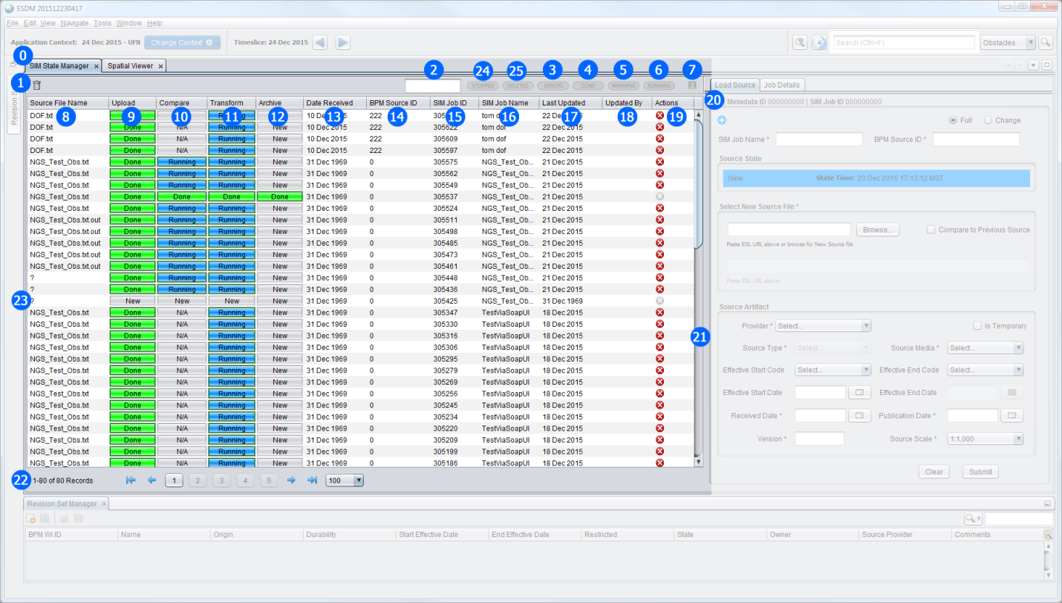

Figure 2

## State Manager UI Elements and Associated Behaviors

1. **SIM State Manager Panel** – Introduces the concept of a SIM Job which provides a comprehensive and detailed view into each source’s processing states. UI updates when new source is submitted and a SIM Job is created as well as when a source transitions from one state to another.
   1. **Minimum Panel Size** **–** Width 600 x Height 620
   2. **Scrolling** – on lower resolution screens the panel will provide necessary scrollbar(s) for access to full panel
2. **Delete Job** button – Located in the top left
   1. **Help** Balloon text “Delete selected SIM Job(s)“
   2. Disabled until one or more rows selected
   3. **Validation 1:** Job in row(s) selected must be stopped; analyst cannot delete a running or completed SIM Job
3. **Text Filter** text field (type ahead filter) – a quick filter to find records containing the entered characters
   1. **Help** Balloon text “Type characters to filter table results“
   2. As the analyst types the displayed number of matching results in the table below (#23) are reduced
   3. If individual characters are deleted or field cleared of all characters the matching results will reflect records which contain the current characters
   4. The matching characters will be highlighted in the table results
4. **Errors Filter** toggle button –
   1. **Help** Balloon text “Show all SIM Jobs with Errors“
   2. **Default State**: Off
   3. **Toggle - On**: The table updates to show only those SIM Jobs which contain an Error state
   4. **Toggle** – **Off**: The table updates to show all records not filtered out by other filter conditions
5. **Done Filter** toggle button
   1. **Help** Balloon text “Show all Complete SIM Jobs“
   2. **Default State**: Off
   3. **Toggle - On**: The table updates to show only those SIM Jobs which contain a Done state
   4. **Toggle** – **Off**: The table updates to show all records not filtered out by other filter conditions
6. **Warning Filter** toggle button
   1. **Help** Balloon text “Show all SIM Jobs with Warnings“
   2. **Default State**: Off
   3. **Toggle - On**: The table updates to show only those SIM Jobs which contain a Warning state
   4. **Toggle** – **Off**: The table updates to show all records not filtered out by other filter conditions
7. **Running Filter** toggle button
   1. **Help** Balloon text “Show all SIM Jobs currently running“
   2. **Default State**: Off
   3. **Toggle - On**: The table updates to show only those SIM Jobs which contain a Running state
   4. **Toggle** – **Off**: The table updates to show all records not filtered out by other filter conditions
8. **My Jobs Filter** toggle button
   1. **Help** Balloon text “Show only SIM Jobs I have submitted“
   2. **Default State**: Off
   3. **Toggle - On**: The table updates to show only those SIM Jobs which the logged in user has submitted
   4. **Toggle** – **Off**: The table updates to show all records not filtered out by other filter conditions
9. **Source File Name** table column – Required
   1. **Sortable**: Yes [Ascending, Descending, OFF]
   2. **Expandable**: Yes
   3. **Action**: Clicking a row in this column highlights the row and triggers an update to the **Load Source** panel to display this SIM Job’s metadata
10. **Upload** custom table cell with progress bar – Required
    1. **Sortable**: Yes [Ascending, Descending, OFF]
    2. **Expandable**: Yes
    3. **Possible States**:
       1. **New** [Background: FAA White Shade 2 (200,200,200)] – displayed for new SIM Job before **Upload** processing begins
       2. **Running** [Background: FAA Cyan Shade 1 (0,145,255)] – displayed after SIM Job **Upload** processing begins
          1. **Progress Text**: “xx%”
          2. **On Complete (100%)**: Display as ‘Done’ (#iv)
       3. **Stopped** [Background: FAA Red Shade 2 (200,0,0)] – displayed when analyst has stopped a running job during this state
       4. **Done** [Background: FAA Green Shade 1 (0,255,0)] – displayed when SIM Job has successfully completed current state
       5. **Error** [Background: FAA Red Shade 2 (200,0,0)] – displayed when current state has stopped due to error
       6. **Warning** [Background: FAA Amber Shade 1 (255,180,0)] – displayed when system encounters a warning condition but processing of SIM Job continues
       7. **Deleted** [Background: FAA Red Shade 3 (160,0,0)] – displayed when a SIM Job has been deleted
    4. **Action**: Clicking a row in this column highlights the row and triggers an update to the **Job Details- Upload State** panel to display the details of this SIM Job
       1. Brings **Upload State** Job Details panel to the forefront
11. **Compare** custom table cell with progress bar – Required
    1. **Sortable**: Yes [Ascending, Descending, OFF]
    2. **Expandable**: Yes
    3. **Possible States**:
       1. **N/A** [Background: FAA White Shade 2 (200,200,200)] – displayed if **Compare to Previous Source** functionality not selected during **Load Source**
       2. **New** [Background: FAA White Shade 2 (200,200,200)] – displayed before **Compare** processing begins
       3. **Running** [Background: FAA Cyan Shade 1 (0,145,255)] – displayed after SIM Job **Compare** processing begins
          1. **Progress Text**: “xx%”
          2. **On Complete (100%)**: Display as ‘Done’ (#v)
       4. **Stopped** [Background: FAA Red Shade 2 (200,0,0)] – displayed when analyst has stopped a running job during this state
       5. **Done** [Background: FAA Green Shade 1 (0,255,0)] – displayed when SIM Job has successfully completed current state
       6. **Error** [Background: FAA Red Shade 2 (200,0,0)] – displayed when current state has stopped due to error
       7. **Warning** [Background: FAA Amber Shade 1 (255,180,0)] – displayed when system encounters a warning condition but processing of SIM Job continues
       8. **Deleted** [Background: FAA Red Shade 3 (160,0,0)] – displayed when a SIM Job has been deleted
    4. **Action**: Clicking a row in this column highlights the row and triggers an update to the **Job Details- Compare State** panel to display the details of this SIM Job
       1. Brings **Compare State** Job Details panel to the forefront
12. **Transform** custom table cell with progress bar – Required
    1. **Sortable**: Yes [Ascending, Descending, OFF]
    2. **Expandable**: Yes
    3. **Possible States**:
       1. **New** [Background: FAA White Shade 2 (200,200,200)] – displayed before **Transform** processing begins
       2. **Running** [Background: FAA Cyan Shade 1 (0,145,255)] – displayed after SIM Job **Transform** processing begins
          1. **Progress Text**: “xx%”
          2. **On Complete (100%)**: Display as ‘Done’ (#iv)
       3. **Stopped** [Background: FAA Red Shade 2 (200,0,0)] – displayed when analyst has stopped a running job during this state
       4. **Done** [Background: FAA Green Shade 1 (0,255,0)] – displayed when SIM Job has successfully completed current state
       5. **Error** [Background: FAA Red Shade 2 (200,0,0)] – displayed when current state has stopped due to error
       6. **Warning** [Background: FAA Amber Shade 1 (255,180,0)] – displayed when system encounters a warning condition but processing of SIM Job continues
       7. **Deleted** [Background: FAA Red Shade 3 (160,0,0)] – displayed when a SIM Job has been deleted
    4. **Action**: Clicking a row in this column highlights the row and triggers an update to the **Job Details- Transform State** panel to display the details of this SIM Job
       1. Brings **Transform State** Job Details panel to the forefront
13. **Archive** custom table cell with progress bar – Required
    1. **Sortable**: Yes [Ascending, Descending, OFF]
    2. **Expandable**: Yes
    3. **Possible States**:
       1. **New** [Background: FAA White Shade 2 (200,200,200)] – displayed before **Archive** processing begins
       2. **Running** [Background: FAA Cyan Shade 1 (0,145,255)] – displayed after SIM Job **Archive** processing begins
          1. **Progress Text**: “xx%”
          2. **On Complete (100%)**: Display as ‘Done’ (#iv)
       3. **Stopped** [Background: FAA Red Shade 2 (200,0,0)] – displayed when analyst has stopped a running job during this state
       4. **Done** [Background: FAA Green Shade 1 (0,255,0)] – displayed when SIM Job has successfully completed current state
       5. **Error** [Background: FAA Red Shade 2 (200,0,0)] – displayed when current state has stopped due to error
       6. **Warning** [Background: FAA Amber Shade 1 (255,180,0)] – displayed when system encounters a warning condition but processing of SIM Job continues
       7. **Deleted** [Background: FAA Red Shade 3 (160,0,0)] – displayed when a SIM Job has been deleted
    4. **Action**: Clicking a row in this column highlights the row and triggers an update to the **Job Details- Archive State** panel to display the details of this SIM Job
       1. Brings **Archive State** Job Details panel to the forefront
14. **Date Received** table column – Optional, displayed by Default
    1. **Date Format:** DD Mon YYYY
    2. **Sortable**: Yes [Ascending, Descending, OFF]
    3. **Expandable**: Yes
    4. **Action**: Clicking a row in this column highlights the row and triggers an update to the **Load Source** panel to display this SIM Job’s metadata
15. **BPM Source ID** table column – Optional, displayed by Default
    1. **Sortable**: Yes [Ascending, Descending, OFF]
    2. **Expandable**: Yes
    3. **Action**: Clicking a row in this column highlights the row and triggers an update to the **Load Source** panel to display this SIM Job’s metadata
16. **SIM Job ID** table column – Optional, displayed by Default
    1. **Sortable**: Yes [Ascending, Descending, OFF]
    2. **Expandable**: Yes
    3. **Action**: Clicking a row in this column highlights the row and triggers an update to the **Load Source** panel to display this SIM Job’s metadata
17. **SIM Job Name** table column – Optional, displayed by Default
    1. **Sortable**: Yes [Ascending, Descending, OFF]
    2. **Expandable**: Yes
    3. **Action**: Clicking a row in this column highlights the row and triggers an update to the **Load Source** panel to display this SIM Job’s metadata
18. **Last Updated** table column – Optional, displayed by Default
    1. **Date Format:** DD Mon YYYY
    2. **Sortable**: Yes [Ascending, Descending, OFF]
    3. **Expandable**: Yes
    4. **Action**: Clicking a row in this column highlights the row and triggers an update to the **Load Source** panel to display this SIM Job’s metadata
19. **Updated By** table column – Optional, displayed by Default
    1. **Sortable**: Yes [Ascending, Descending, OFF]
    2. **Expandable**: Yes
    3. **Action**: Clicking a row in this column highlights the row and triggers an update to the **Load Source** panel to display this SIM Job’s metadatametadata
20. **Actions** table column – Required
    1. **Sortable**: No
    2. **Expandable**: Yes
    3. **Action**: Clicking the **Stop** button stops processing on the selected SIM Job and performs a system wide roll back. [NOTE: If the analyst wants to restart the SIM Job they have to click the **Submit** button from the **Load Source** panel.]
21. **Column Selector** widget – a popup dialog which allows the analyst to select or deselect for display any optional table columns
    1. Analyst is not allowed to deselect Required columns for display
    2. Once analyst selects columns to display in view and chooses to close dialog the table view refreshes to display selected columns
       1. All sorting, filtering, etc. remain set as they were before column selection
    3. Analyst can choose to cancel dialog and no change will manifest in the table view
22. **Scroll Bar** – table view scrolling available if amount of records displayed exceeds viewable application space
23. **Pagination** ‘control’
    1. **Current Records Displayed** text: “n-n of nn Records” ex. 1-100 of 240 Records
    2. **Buttons**:
       1. **Jump to First Page** button
          1. **Help** Balloon text “Jump to first page“
          2. Disabled if table currently displaying first or only page
       2. **Jump to Previous Page** button
          1. **Help** Balloon text “Jump to previous page“
          2. Disabled if table currently displaying first or only page
       3. **Page Selection Function** buttons
          1. **Help** Balloon text “Jump to page ‘x’“ where x = button number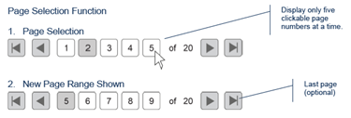
       4. **Jump to Next Page** button
          1. **Help** Balloon text “Jump to next page“
          2. Disabled if table currently displaying last or only page
       5. **Jump to Last Page** button
          1. **Help** Balloon text “Jump to last page“
          2. Disabled if table currently displaying last or only page
       6. **Number of Records to Display Per Page** combo box
          1. **Help** Balloon text “Number of records to display per page“
          2. **List of Values**:
             1. 100
             2. 500
             3. 1000
             4. All
          3. Defaults to 100 records displayed per page
24. **State Manager** table – displays all SIM Jobs and current state
25. **Stopped Filter** toggle button
    1. **Help** Balloon text “Show all stopped SIM Jobs“
    2. **Default State**: Off
    3. **Toggle - On**: The table updates to show only those SIM Jobs which contain stopped SIM Jobs
    4. **Toggle** – **Off**: The table updates to show all records not filtered out by other filter conditions
26. **Deleted Filter** toggle button
    1. **Help** Balloon text “Show all deleted SIM Jobs“
    2. **Default State**: Off
    3. **Toggle - On**: The table updates to show only those SIM Jobs which contain deleted SIM Jobs
    4. **Toggle** – **Off**: The table updates to show all records not filtered out by other filter conditions

### 

NOTE ON FILTERS: Selecting more than one filter will display results in the table which contain either of the filter conditions (an OR search). The exception to this is when text is entered into the Text Filter field which will result in the display of records containing any of the other filters AND the text entered.

# State Manager Job Details

## Overview

The SIM State Manager Job Details panels provide the analyst insight into each processing state of a Source file ingest. There is one details panel per SIM processing state (Upload, Compare, Transform, & Archive)

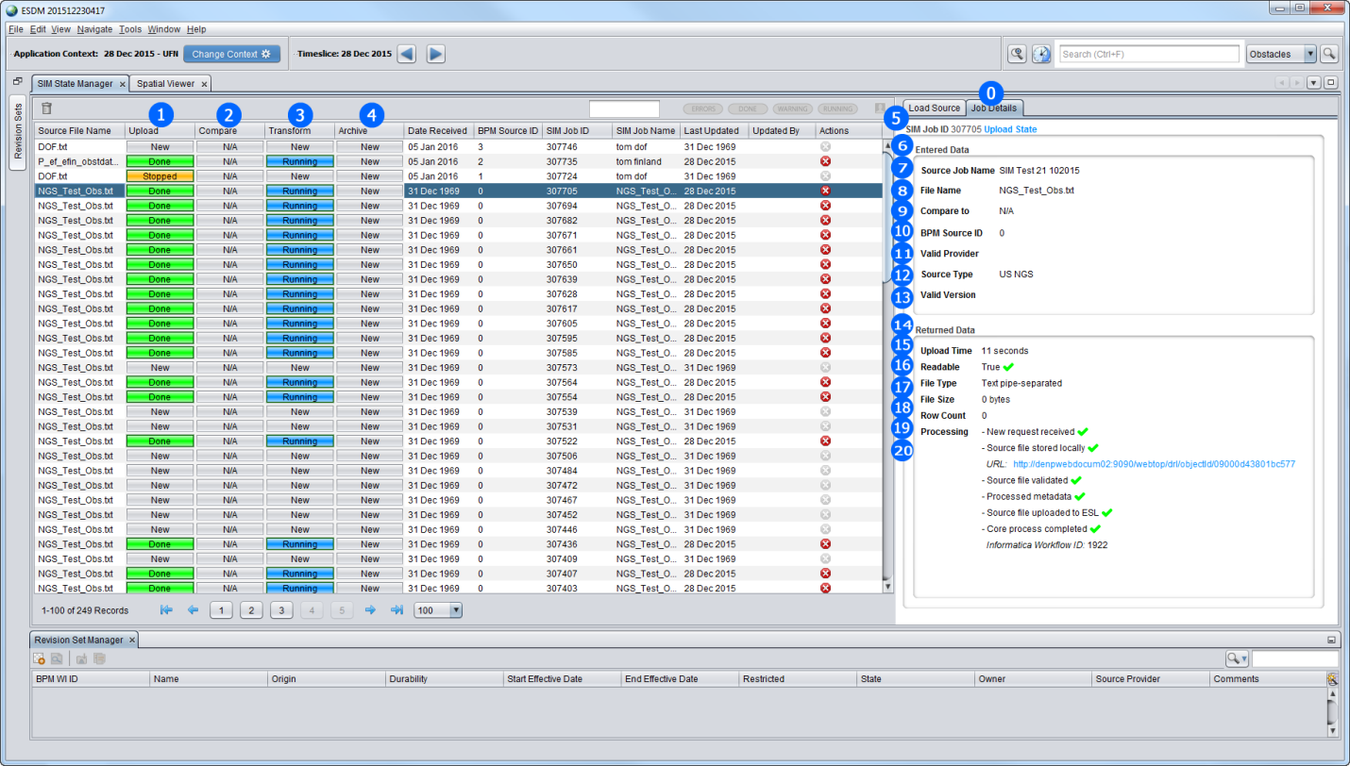

Figure 3

## Job Details UI Elements and Associated Behaviors

1. **Job Details Panel** – Allows the user to see all of the processing steps within a particular SIM Job state as well as view error messages, ESL URLs, and rejection file links.
   1. **Minimum Panel Size** **–** Width 586 x Height 646
   2. **Scrolling** – on lower resolution screens the panel will provide necessary scrollbar(s) for access to full panel contents
2. **Upload State** progress bar – custom table cell, one per row, ‘clickable’
   1. **Help** Balloon text “Show Upload Details“
   2. Will not show details until Upload state completes
3. **Compare State** progress bar – custom table cell, one per row, ‘clickable’
   1. **Help** Balloon text “Show Compare Details“
   2. Will not show details until Compare state completes
4. **Transform State** progress bar – custom table cell, one per row, ‘clickable’
   1. **Help** Balloon text “Show Transform Details“
   2. Will not show details until Transform state completes
5. **Archive State** progress bar – custom table cell, one per row, ‘clickable’
   1. **Help** Balloon text “Show Archive Details“
   2. Will not show details until Archive state completes
6. **Upload State Details Panel -** Located in the BorderTitle (HTML formatted)
   1. **SIM Job ID** – Read Only, bold label, plain value
      1. System generated ID value is populated as part of ***Upload State*** processing
   2. **Upload State** – state identifier text
      1. Color coded to current state
7. **Entered Data** **-** Located in the BorderTitle (HTML formatted)
   1. Text “Entered Data” is read only
8. **Source Job Name** - Read Only, bold label, plain value
9. **File Name** - Read Only, bold label, plain value
10. **Compare To** - Read Only, bold label, plain value
11. **BPM Source ID** - Read Only, bold label, plain value
12. **Valid Provider** - Read Only, bold label, plain value
13. **Source Type** - Read Only, bold label, plain value
14. **Valid Version** - Read Only, bold label, plain value
15. **Returned Data** - Located in the BorderTitle (HTML formatted)
    1. Text “Returned Data” is read only
16. **Upload Time** - Read Only, bold label, plain value
17. **Readable** - Read Only, bold label, plain value
18. **File Type** - Read Only, bold label, plain value
19. **File Size** - Read Only, bold label, plain value
20. **Row Count** - Read Only, bold label, plain value
21. **Processing** - Read Only, bold label, plain value
    1. New request received
    2. Source file stored locally
    3. URL
    4. Source file validated
    5. Processed metadata
    6. Source file uploaded to ESL
    7. Core process completed
    8. Informatica Workflow ID [optional: as applicable]

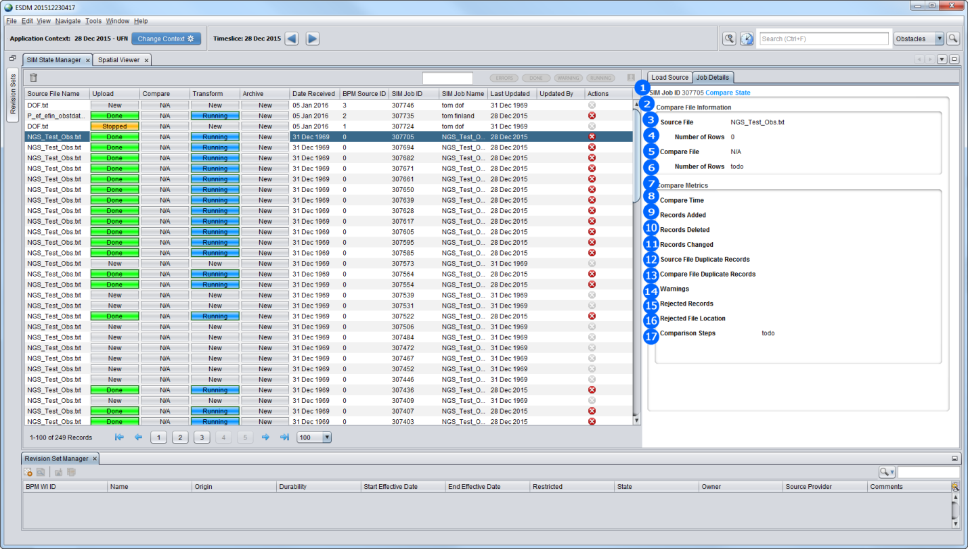

Figure 4

## UI304 Compare State UI Elements and Associated Behaviors

1. **Compare State Details Panel -** Located in the BorderTitle (HTML formatted)
   1. **SIM Job ID** – Read Only, bold label, plain value
      1. System generated ID value is populated as part of ***Upload State*** processing
   2. **Compare State** – state identifier text
      1. Color coded to current state
2. **Compare File Information** **-** Located in the BorderTitle (HTML formatted)
3. **Source File** - Read Only, bold label, plain value
4. **Number of Rows** - Read Only, bold label, plain value
5. **Compare File** - Read Only, bold label, plain value
6. **Number of Rows** - Read Only, bold label, plain value
7. **Compare Metrics** - Located in the BorderTitle (HTML formatted)
8. **Compare Time** - Read Only, bold label, plain value
9. **Records Added** - Read Only, bold label, plain value
10. **Records Deleted** - Read Only, bold label, plain value
11. **Records Changed** - Read Only, bold label, plain value
12. **Source File Duplicate Records** - Read Only, bold label, plain value
13. **Compare File Duplicate Records** - Read Only, bold label, plain value
14. **Warnings** - Read Only, bold label, plain value
15. **Rejected Records** - Read Only, bold label, plain value
16. **Rejected File Location** - Read Only, bold label, plain value
17. **Comparison Steps** - Read Only, bold label, plain value

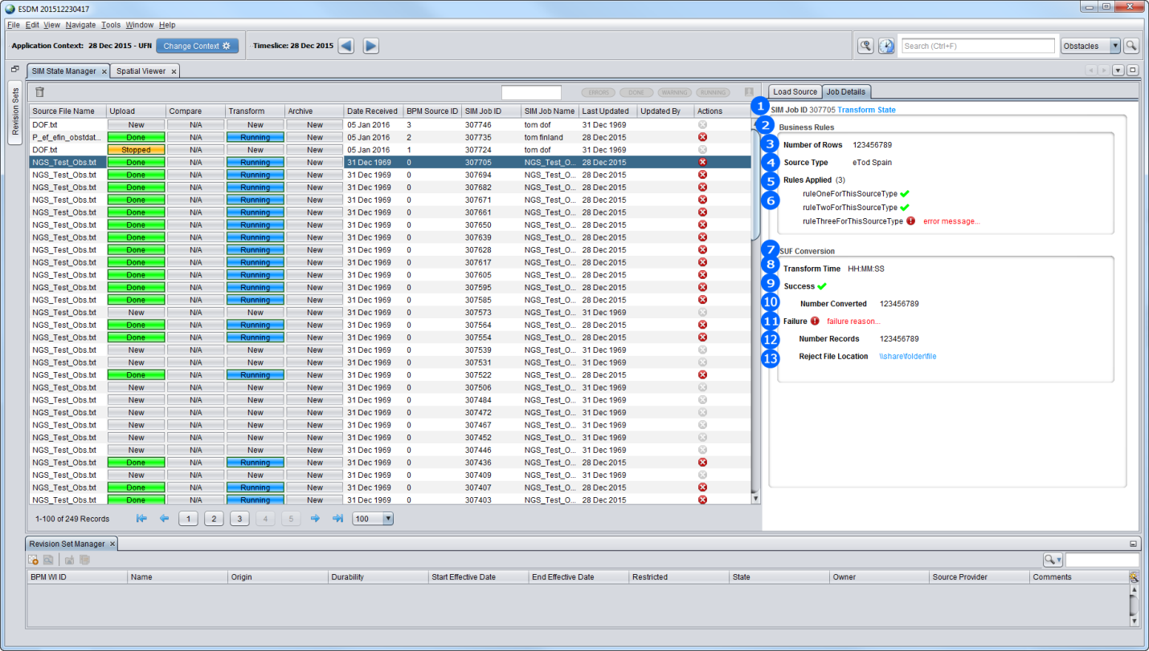

Figure 5

## Transform State UI Elements and Associated Behaviors

1. **Transform State Details Panel -** Located in the BorderTitle (HTML formatted)
   1. **SIM Job ID** – Read Only, bold label, plain value
      1. System generated ID value is populated as part of ***Upload State*** processing
   2. **Transform State** – state identifier text
      1. Color coded to current state
2. **Business Rules** **-** Located in the BorderTitle (HTML formatted)
3. **Number of Rows** - Read Only, bold label, plain value
4. **Source Type** - Read Only, bold label, plain value
5. **Rules Applied (#)** - Read Only, bold label, plain value
   1. Displays a count of the total number of transformation rules applied to source
6. Listing of rules applied to source, one per row
7. **SUF Conversion** - Located in the BorderTitle (HTML formatted)
8. **Transform Time** - Read Only, bold label, plain value [HH:MM:SS]
9. **Success** - Read Only, bold label, checkmark value
   1. Only displays if Transform successful
10. **Number Converted** - Read Only, bold label, plain value
    1. Only displays if Transform successful
11. **Failure** - Read Only, bold label, exclamation value + failure reason text
    1. Only displays if Transform fails
12. **Number Records** - Read Only, bold label, plain value
    1. Only displays if Transform fails
13. **Reject File Location** - Read Only, bold label, plain value
    1. Only displays if Transform fails

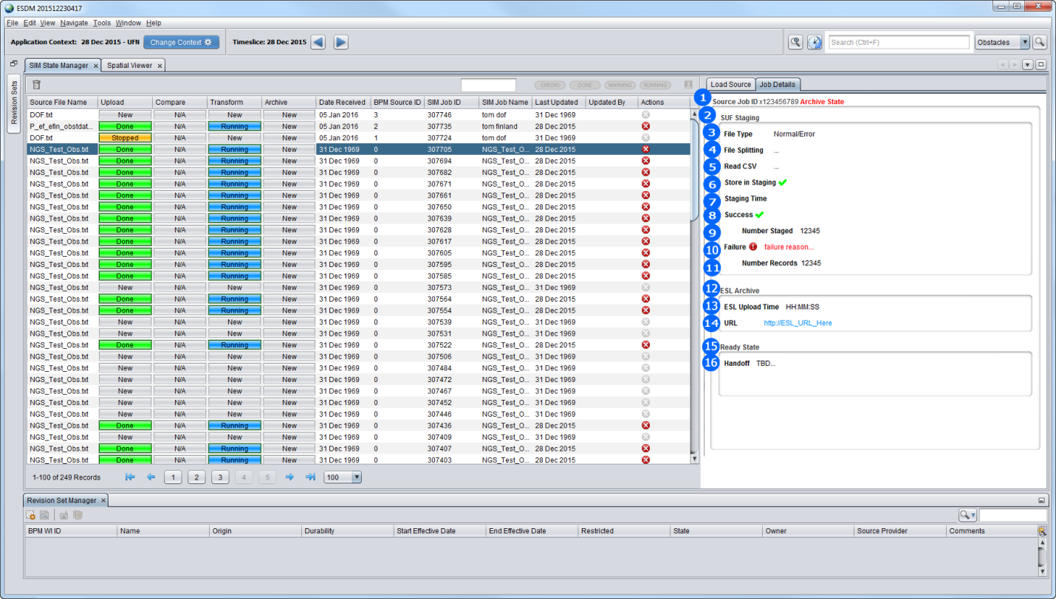

Figure 6

## Archive State UI Elements and Associated Behaviors

1. **Archive State Details Panel -** Located in the BorderTitle (HTML formatted)
   1. **SIM Job ID** – Read Only, bold label, plain value
      1. System generated ID value is populated as part of ***Upload State*** processing
   2. **Archive State** – state identifier text
      1. Color coded to current state
2. **SUF Staging** **-** Located in the BorderTitle (HTML formatted)
3. **File Type** – [value: either Normal or Error] Read Only, bold label, plain value
4. **File Splitting** - Read Only, bold label, plain value […]
5. **Read CSV** - Read Only, bold label, plain value […]
   1. Displays a count of the total number of transformation rules applied to source
6. **Store in Staging -** Read Only, bold label,
   1. **On Success:** checkmark value
   2. **On Failure**: error value
7. **Staging Time** - Read Only, bold label, plain value [HH:MM:SS]
8. **Success** - Read Only, bold label, checkmark value
   1. Only displays if Staging is successful
9. **Number Staged** - Read Only, bold label, plain value
   1. Only displays if Staging successful
10. **Failure** - Read Only, bold label, exclamation value + failure reason text
    1. Only displays if Staging fails
11. **Number Records** - Read Only, bold label, plain value
    1. Only displays if Staging fails
12. **ESL Archive** - Located in the BorderTitle (HTML formatted)
13. **ESL Upload Time** - Read Only, bold label, plain value [HH:MM:SS]
14. **URL** - Read Only, bold label, plain hotlinked value
    1. Only displays if ESL Archive successful
15. **Ready State** - Located in the BorderTitle (HTML formatted)
16. **Handoff** - Read Only, bold label, [TBD…]

### Business Rules

Not Applicable.

### Supplemental Requirements

#### Global Supplemental Requirements

Not Applicable.

#### Local Supplemental Requirements

None.

## Dependencies

|  |  |  |
| --- | --- | --- |
| Dependency Type | Description | Location |
|  |  |  |
|  |  |  |
|  |  |  |
|  |  |  |
|  |  |  |

# Future Requirements – Post R1

## Overview

This section is reserved for requirements that may have been moved out of a release but need to be kept in-context within this document. The following SRL sub-epics have been classified as Post R1 in the SRL and will not have test cases written against them.

## Applicable Sub-Epics

### Unstructured Source – SRL Feature ID#

### Create BPM - SRL Feature ID#

### UI for ESL/Documentum - SRL Feature ID#

### 

# Appendix A – Provider to Source Table

The source for this document is located at:

|  |  |  |  |  |  |  |  |
| --- | --- | --- | --- | --- | --- | --- | --- |
| ID | JODA_CD | FRMT_ SEQNBR | SIM_DEV_ SEQNBR | SIM_PROV_TXT | SIM_FRMT_TXT | COVRG_AREA | comments |
| 500011 | 50001 | 1 | 1 | MISC | UNIV_SPEC_FILE | Misc use worldwide | "Last resort" until a new format can be added to SIM |
| 71 | 7 | 1 | 2 | USA_FAA | DOF_FULL_DAT | USA and possns |  |
| 82 | 8 | 2 | 3 | USA_FAA | DOF_CHANGE_DAT | USA and possns | note that JS decided no Univ Spec File option for DOF; also for SIM interface cannot choose this plus check SIM Compare checkbox |
| 651 | 65 | 1 | 4 | AIP_FINLAND | eTOD_FNLND_CSV | Finland and possns |  |
| 652 | 65 | 2 | 5 | AIP_FINLAND | UNIV_SPEC_FILE | Finland and possns |  |
| 18691 | 1869 | 1 | 6 | USA_NGS_ODS | NGS_ODS_TXT | USA airport surveys |  |
| 18692 | 1869 | 2 | 7 | USA_NGS_ODS | UNIV_SPEC_FILE | USA airport surveys |  |
| 551 | 55 | 1 | 8 | AIP_UK_CIVILIAN | eTOD_UKCIVALL_EXCL | UK civilian airports |  |
| 552 | 55 | 2 | 9 | AIP_UK_CIVILIAN | UNIV_SPEC_FILE | UK civilian airports |  |
| 1721 | 172 | 1 | 10 | AIP_SPAIN | eTOD_SPN_ARPT1_CSV | Spain and possns |  |
| 1722 | 172 | 2 | 11 | AIP_SPAIN | eTOD_SPN_ARPT2_CSV | Spain and possns |  |
| 1723 | 172 | 3 | 12 | AIP_SPAIN | eTOD_SPN_ENR_CSV | Spain and possns |  |
| 1724 | 172 | 4 | 13 | AIP_SPAIN | UNIV_SPEC_FILE | Spain and possns |  |
| 17341 | 1734 | 1 | 14 | AIP_TURKEY | eTOD_TURKARPT_EXCL | Turkey and possns |  |
| 17342 | 1734 | 2 | 15 | AIP_TURKEY | eTOD_TURKENR_EXCL | Turkey and possns |  |
| 17343 | 1734 | 3 | 16 | AIP_TURKEY | UNIV_SPEC_FILE | Turkey and possns |  |
| 18691 | 1869 | 1 | 17 | USA_DVOF | DVOF_FULL_TXT | Many nations not just USA |  |
| 18692 | 1869 | 2 | 18 | USA_DVOF | UNIV_SPEC_FILE | Many nations not just USA |  |
| 23411 | 2341 | 1 | 19 | UK_RAF_RESTRICTED | UK_RAF_RESTRICTED | UK royal airforce data |  |
| 23412 | 2341 | 2 | 20 | UK_RAF_RESTRICTED | UNIV_SPEC_FILE | UK royal airforce data |  |
| 1051 | 105 | 1 | 21 | AIP_LATVIA | eTOD_LATVIA_XML | Latvia |  |
| 1052 | 105 | 2 | 22 | AIP_LATVIA | UNIV_SPEC_FILE | Latvia |  |
| 1031 | 103 | 1 | 23 | AIP_SWITZERLAND | eTOD_SWISS_XML | Switzerland |  |
| 1032 | 103 | 2 | 24 | AIP_SWITZERLAND | UNIV_SPEC_FILE | Switzerland |  |
| 61 | 6 | 1 |  | NIMA ECHUM | UNIV_SPEC_FILE |  |  |
| 171 | 17 | 1 |  | AIP CAR/SAM/NAM | UNIV_SPEC_FILE |  |  |
| 181 | 18 | 1 |  | AIP ARUBA | UNIV_SPEC_FILE |  |  |
| 191 | 19 | 1 |  | AIP EASTERN CARRIBEAN | UNIV_SPEC_FILE |  |  |
| 201 | 20 | 1 |  | AIP PANAMA | UNIV_SPEC_FILE |  |  |
| 221 | 22 | 1 |  | AIP BERMUDA | UNIV_SPEC_FILE |  |  |
| 231 | 23 | 1 |  | AIP COLOMBIA | UNIV_SPEC_FILE |  |  |
| 241 | 24 | 1 |  | AIP Guyana | UNIV_SPEC_FILE |  |  |
| 251 | 25 | 1 |  | AIP JAPAN | UNIV_SPEC_FILE |  |  |
| 281 | 28 | 1 |  | AIP Vietnam | UNIV_SPEC_FILE |  |  |
| 331 | 33 | 1 |  | AIP CANADA | UNIV_SPEC_FILE |  |  |
| 561 | 56 | 1 |  | AIP SLOVAK REPUBLIC | UNIV_SPEC_FILE |  |  |
| 571 | 57 | 1 |  | AIP DENMARK | UNIV_SPEC_FILE |  |  |
| 581 | 58 | 1 |  | AIP Belgium and G.D Luxembourg | UNIV_SPEC_FILE |  |  |
| 601 | 60 | 1 |  | AIP BAHRAIN FIR | UNIV_SPEC_FILE |  |  |
| 611 | 61 | 1 |  | AIP CZECH REPUBLIC | UNIV_SPEC_FILE |  |  |
| 671 | 67 | 1 |  | AIP HONG KONG | UNIV_SPEC_FILE |  |  |
| 681 | 68 | 1 |  | AIP GHANA | UNIV_SPEC_FILE |  |  |
| 691 | 69 | 1 |  | AIP MALDIVES | UNIV_SPEC_FILE |  |  |
| 701 | 70 | 1 |  | AIP Republic of Mauritius | UNIV_SPEC_FILE |  |  |
| 721 | 72 | 1 |  | AIP SEYCHELLES | UNIV_SPEC_FILE |  |  |
| 791 | 79 | 1 |  | AIP MALAYSIA | UNIV_SPEC_FILE |  |  |
| 1061 | 106 | 1 |  | AIP LITHUANIA | UNIV_SPEC_FILE |  |  |
| 1071 | 107 | 1 |  | AIP SAUDI ARABIA | UNIV_SPEC_FILE |  |  |
| 1081 | 108 | 1 |  | AIP Cabo Verde | UNIV_SPEC_FILE |  |  |
| 1101 | 110 | 1 |  | AIP IRELAND | UNIV_SPEC_FILE |  |  |
| 1111 | 111 | 1 |  | AIP GREENLAND | UNIV_SPEC_FILE |  |  |
| 1131 | 113 | 1 |  | AIP ISLAMIC REPUBLIC OF IRAN | UNIV_SPEC_FILE |  |  |
| 1271 | 127 | 1 |  | AIP TUNISIA | UNIV_SPEC_FILE |  |  |
| 1281 | 128 | 1 |  | AIP ICELAND | UNIV_SPEC_FILE |  |  |
| 1301 | 130 | 1 |  | AIP UGANDA | UNIV_SPEC_FILE |  |  |
| 1311 | 131 | 1 |  | AIP EGYPT | UNIV_SPEC_FILE |  |  |
| 1321 | 132 | 1 |  | AIP BANGLADESH | UNIV_SPEC_FILE |  |  |
| 1331 | 133 | 1 |  | AIP UNITED ARAB EMIRATES | UNIV_SPEC_FILE |  |  |
| 1341 | 134 | 1 |  | AIP Mongolia | UNIV_SPEC_FILE |  |  |
| 1361 | 136 | 1 |  | AIP ESTONIA | UNIV_SPEC_FILE |  |  |
| 1371 | 137 | 1 |  | AIP BOTSWANA , REPUBLIC OF | UNIV_SPEC_FILE |  |  |
| 1401 | 140 | 1 |  | AIP SOUTH AFRICA | UNIV_SPEC_FILE |  |  |
| 1421 | 142 | 1 |  | AIP CYPRUS | UNIV_SPEC_FILE |  |  |
| 1431 | 143 | 1 |  | AIP Austria | UNIV_SPEC_FILE |  |  |
| 1441 | 144 | 1 |  | AIP ITALY | UNIV_SPEC_FILE |  |  |
| 1481 | 148 | 1 |  | AIP HUNGARY | UNIV_SPEC_FILE |  |  |
| 1551 | 155 | 1 |  | AIP REPUBLIC OF YEMEN | UNIV_SPEC_FILE |  |  |
| 1561 | 156 | 1 |  | AIP PORTUGAL | UNIV_SPEC_FILE |  |  |
| 1571 | 157 | 1 |  | AIP NORWAY | UNIV_SPEC_FILE |  |  |
| 1621 | 162 | 1 |  | AIP POLAND | UNIV_SPEC_FILE |  |  |
| 1661 | 166 | 1 |  | AIP PAKISTAN | UNIV_SPEC_FILE |  |  |
| 1861 | 186 | 1 |  | AIP GEORGIA | UNIV_SPEC_FILE |  |  |
| 1871 | 187 | 1 |  | AIP SYRIA | UNIV_SPEC_FILE |  |  |
| 1881 | 188 | 1 |  | AIP INDIA | UNIV_SPEC_FILE |  |  |
| 1911 | 191 | 1 |  | AIP TUVALU | UNIV_SPEC_FILE |  |  |
| 2091 | 209 | 1 |  | AIP PERU | UNIV_SPEC_FILE |  |  |
| 2101 | 210 | 1 |  | AIP ECUADOR | UNIV_SPEC_FILE |  |  |
| 2121 | 212 | 1 |  | AIP HONDURAS | UNIV_SPEC_FILE |  |  |
| 2131 | 213 | 1 |  | AIP BARBADOS | UNIV_SPEC_FILE |  |  |
| 2141 | 214 | 1 |  | AIP Kingdom of Cambodia | UNIV_SPEC_FILE |  |  |
| 2151 | 215 | 1 |  | AIP CAYMAN ISLANDS | UNIV_SPEC_FILE |  |  |
| 2161 | 216 | 1 |  | AIP REPUBLIC OF KOREA | UNIV_SPEC_FILE |  |  |
| 2171 | 217 | 1 |  | AIP SINGAPORE | UNIV_SPEC_FILE |  |  |
| 2181 | 218 | 1 |  | AIP URUGUAY | UNIV_SPEC_FILE |  |  |
| 2371 | 237 | 1 |  | AIP AUSTRALIA | UNIV_SPEC_FILE |  |  |
| 2391 | 239 | 1 |  | AIP PACIFIC | UNIV_SPEC_FILE |  |  |
| 2401 | 240 | 1 |  | AIP Thailand | UNIV_SPEC_FILE |  |  |
| 15101 | 1510 | 1 |  | AIP BRAZIL | UNIV_SPEC_FILE |  |  |
| 15111 | 1511 | 1 |  | AIP ARGENTINA | UNIV_SPEC_FILE |  |  |
| 15121 | 1512 | 1 |  | AIP CHILE | UNIV_SPEC_FILE |  |  |
| 15131 | 1513 | 1 |  | AIP SURINAME | UNIV_SPEC_FILE |  |  |
| 15141 | 1514 | 1 |  | AIP NETHERLANDS ANTILLES | UNIV_SPEC_FILE |  |  |
| 15151 | 1515 | 1 |  | AIP MEXICO | UNIV_SPEC_FILE |  |  |
| 15161 | 1516 | 1 |  | AIP HAITI | UNIV_SPEC_FILE |  |  |
| 15171 | 1517 | 1 |  | AIP DOMINICAN REPUBLIC | UNIV_SPEC_FILE |  |  |
| 15181 | 1518 | 1 |  | AIP French Guiana | UNIV_SPEC_FILE |  |  |
| 15191 | 1519 | 1 |  | AIP JAMACIA | UNIV_SPEC_FILE |  |  |
| 15201 | 1520 | 1 |  | AIP PARAGUAY | UNIV_SPEC_FILE |  |  |
| 17041 | 1704 | 1 |  | AIP Algeria | UNIV_SPEC_FILE |  |  |
| 17051 | 1705 | 1 |  | AIP Angola | UNIV_SPEC_FILE |  |  |
| 17061 | 1706 | 1 |  | AIP ASECNA | UNIV_SPEC_FILE |  |  |
| 17111 | 1711 | 1 |  | AIP Djibouti | UNIV_SPEC_FILE |  |  |
| 17131 | 1713 | 1 |  | AIP Ethiopia | UNIV_SPEC_FILE |  |  |
| 17141 | 1714 | 1 |  | AIP France | UNIV_SPEC_FILE |  |  |
| 17151 | 1715 | 1 |  | AIP Greece | UNIV_SPEC_FILE |  |  |
| 17171 | 1717 | 1 |  | AIP Jordan | UNIV_SPEC_FILE |  |  |
| 17181 | 1718 | 1 |  | AIP Kenya | UNIV_SPEC_FILE |  |  |
| 17191 | 1719 | 1 |  | AIP KUWAIT | UNIV_SPEC_FILE |  |  |
| 17201 | 1720 | 1 |  | AIP Libya | UNIV_SPEC_FILE |  |  |
| 17211 | 1721 | 1 |  | AIP Malawi | UNIV_SPEC_FILE |  |  |
| 17221 | 1722 | 1 |  | AIP Malta | UNIV_SPEC_FILE |  |  |
| 17241 | 1724 | 1 |  | AIP Namibia | UNIV_SPEC_FILE |  |  |
| 17251 | 1725 | 1 |  | AIP Nepal | UNIV_SPEC_FILE |  |  |
| 17271 | 1727 | 1 |  | AIP Nigeria | UNIV_SPEC_FILE |  |  |
| 17281 | 1728 | 1 |  | AIP Oman | UNIV_SPEC_FILE |  |  |
| 17291 | 1729 | 1 |  | AIP Reunion & Mayotte | UNIV_SPEC_FILE |  |  |
| 17321 | 1732 | 1 |  | AIP Slovenia | UNIV_SPEC_FILE |  |  |
| 17331 | 1733 | 1 |  | AIP Sweden | UNIV_SPEC_FILE |  |  |
| 17361 | 1736 | 1 |  | AIP Zimbabwe | UNIV_SPEC_FILE |  |  |
| 17641 | 1764 | 1 |  | MIL AIP France | UNIV_SPEC_FILE |  |  |
| 17651 | 1765 | 1 |  | MIL AIP Germany | UNIV_SPEC_FILE |  |  |
| 17691 | 1769 | 1 |  | AIP VENEZUELA | UNIV_SPEC_FILE |  |  |
| 17701 | 1770 | 1 |  | AIP TURKS & CAICOS ISLANDS | UNIV_SPEC_FILE |  |  |
| 17721 | 1772 | 1 |  | AIP FRENCH REPUBLIC PAC-P | UNIV_SPEC_FILE |  |  |
| 17731 | 1773 | 1 |  | AIP FRENCH REPUBLIC PAC-N | UNIV_SPEC_FILE |  |  |
| 17751 | 1775 | 1 |  | AIP CROATIA | UNIV_SPEC_FILE |  |  |
| 17811 | 1781 | 1 |  | AIP MOZAMBIQUE | UNIV_SPEC_FILE |  |  |
| 18051 | 1805 | 1 |  | AIP Laos | UNIV_SPEC_FILE |  |  |
| 18071 | 1807 | 1 |  | AIP Papua New Guinea | UNIV_SPEC_FILE |  |  |
| 18091 | 1809 | 1 |  | AIP Bahamas | UNIV_SPEC_FILE |  |  |
| 18111 | 1811 | 1 |  | AIP Brunei | UNIV_SPEC_FILE |  |  |
| 18151 | 1815 | 1 |  | AIP China, Republic of (Taiwan) | UNIV_SPEC_FILE |  |  |
| 18171 | 1817 | 1 |  | AIP Cuba | UNIV_SPEC_FILE |  |  |
| 18211 | 1821 | 1 |  | AIP Guatemala | UNIV_SPEC_FILE |  |  |
| 18271 | 1827 | 1 |  | AIP Myanmar, Union of | UNIV_SPEC_FILE |  |  |
| 18291 | 1829 | 1 |  | AIP New Zealand | UNIV_SPEC_FILE |  |  |
| 18311 | 1831 | 1 |  | AIP Nicaragua | UNIV_SPEC_FILE |  |  |
| 18371 | 1837 | 1 |  | AIP Philippines | UNIV_SPEC_FILE |  |  |
| 18431 | 1843 | 1 |  | AIP Costa Rica | UNIV_SPEC_FILE |  |  |
| 18451 | 1845 | 1 |  | AIP El Salvador | UNIV_SPEC_FILE |  |  |
| 18571 | 1857 | 1 |  | AIP UKRAINE | UNIV_SPEC_FILE |  |  |
| 18671 | 1867 | 1 |  | AIP CONGO | UNIV_SPEC_FILE |  |  |
| 18871 | 1887 | 1 |  | AIP MACAU | UNIV_SPEC_FILE |  |  |
| 18911 | 1891 | 1 |  | AIP MOROCCO | UNIV_SPEC_FILE |  |  |
| 18941 | 1894 | 1 |  | AIP Azerbaijan | UNIV_SPEC_FILE |  |  |
| 18991 | 1899 | 1 |  | AIP KAZAKHSTAN | UNIV_SPEC_FILE |  |  |
| 19011 | 1901 | 1 |  | AIP ZAMBIA | UNIV_SPEC_FILE |  |  |
| 19031 | 1903 | 1 |  | AIP BURUNDI | UNIV_SPEC_FILE |  |  |
| 19061 | 1906 | 1 |  | AIP Turkish Rep.of Northern Cyprus | UNIV_SPEC_FILE |  |  |
| 19071 | 1907 | 1 |  | AIP GAMBIA | UNIV_SPEC_FILE |  |  |
| 19091 | 1909 | 1 |  | AIP BOSNIA AND HERZEGOVINA | UNIV_SPEC_FILE |  |  |
| 19111 | 1911 | 1 |  | AIP SWAZILAND | UNIV_SPEC_FILE |  |  |
| 19121 | 1912 | 1 |  | AIP Bulgaria | UNIV_SPEC_FILE |  |  |
| 19171 | 1917 | 1 |  | AIP CHINA PEOPLES REPUBLIC of | UNIV_SPEC_FILE |  |  |
| 19191 | 1919 | 1 |  | AIP UZBEKISTAN | UNIV_SPEC_FILE |  |  |
| 19211 | 1921 | 1 |  | AIP Roberts FIR | UNIV_SPEC_FILE |  |  |
| 19231 | 1923 | 1 |  | AIP MACEDONIA | UNIV_SPEC_FILE |  |  |
| 19251 | 1925 | 1 |  | AIP SUDAN | UNIV_SPEC_FILE |  |  |
| 19271 | 1927 | 1 |  | AIP RWANDA | UNIV_SPEC_FILE |  |  |
| 19291 | 1929 | 1 |  | AIP MOLDOVA | UNIV_SPEC_FILE |  |  |
| 19311 | 1931 | 1 |  | AIP BOLIVIA | UNIV_SPEC_FILE |  |  |
| 19331 | 1933 | 1 |  | AIP SRI LANKA | UNIV_SPEC_FILE |  |  |
| 19361 | 1936 | 1 |  | AIP ISRAEL | UNIV_SPEC_FILE |  |  |
| 19371 | 1937 | 1 |  | AIP LEBANON | UNIV_SPEC_FILE |  |  |
| 19391 | 1939 | 1 |  | AIP D.P.R. KOREA | UNIV_SPEC_FILE |  |  |
| 19411 | 1941 | 1 |  | AIP BELIZE | UNIV_SPEC_FILE |  |  |
| 19511 | 1951 | 1 |  | AIP FIJI | UNIV_SPEC_FILE |  |  |
| 19571 | 1957 | 1 |  | AIP INDONESIA | UNIV_SPEC_FILE |  |  |
| 19651 | 1965 | 1 |  | US-DOD | UNIV_SPEC_FILE |  |  |
| 19721 | 1972 | 1 |  | AIP TONGA | UNIV_SPEC_FILE |  |  |
| 19811 | 1981 | 1 |  | AIP BUTHAN | UNIV_SPEC_FILE |  |  |
| 19831 | 1983 | 1 |  | AIP Serbia and Montenegro | UNIV_SPEC_FILE |  |  |
| 19851 | 1985 | 1 |  | AIP Yemen | UNIV_SPEC_FILE |  |  |
| 19861 | 1986 | 1 |  | AIP Albania | UNIV_SPEC_FILE |  |  |
| 19891 | 1989 | 1 |  | MIL AIP Italy | UNIV_SPEC_FILE |  |  |
| 19911 | 1991 | 1 |  | AIP KOSOVO | UNIV_SPEC_FILE |  |  |
| 19921 | 1992 | 1 |  | AIP Central Africian Republic | UNIV_SPEC_FILE |  |  |
| 19931 | 1993 | 1 |  | South African Air Force | UNIV_SPEC_FILE |  |  |
| 20121 | 2012 | 1 |  | AIP ROMANIA | UNIV_SPEC_FILE |  |  |
| 20141 | 2014 | 1 |  | AIP Faroe Islands | UNIV_SPEC_FILE |  |  |
| 20261 | 2026 | 1 |  | AIP GERMANY | UNIV_SPEC_FILE |  |  |
| 20341 | 2034 | 1 |  | AIP NETHERLANDS | UNIV_SPEC_FILE |  |  |
| 20721 | 2072 | 1 |  | AIP Tanzania | UNIV_SPEC_FILE |  |  |
| 20741 | 2074 | 1 |  | AIP RUSSIA AND CIS | UNIV_SPEC_FILE |  |  |
| 20861 | 2086 | 1 |  | UK MIL AIP | UNIV_SPEC_FILE |  |  |
| 20881 | 2088 | 1 |  | MIL AIP Portugal | UNIV_SPEC_FILE |  |  |
| 20921 | 2092 | 1 |  | AIP Armenia | UNIV_SPEC_FILE |  |  |
| 21021 | 2102 | 1 |  | MIL AIP NETHERLANDS | UNIV_SPEC_FILE |  |  |
| 21101 | 2110 | 1 |  | AIP Afghanistan | UNIV_SPEC_FILE |  |  |
| 21261 | 2126 | 1 |  | AIP IRAQ | UNIV_SPEC_FILE |  |  |
| 21301 | 2130 | 1 |  | MIL AIP BELGIUM | UNIV_SPEC_FILE |  |  |
| 21401 | 2140 | 1 |  | MIL AIP DENMARK | UNIV_SPEC_FILE |  |  |
| 21421 | 2142 | 1 |  | MIL AIP HUNGARY | UNIV_SPEC_FILE |  |  |
| 22611 | 2261 | 1 |  | AIP SAMOA | UNIV_SPEC_FILE |  |  |
| 23421 | 2342 | 1 |  | MIL AIP POLAND | UNIV_SPEC_FILE |  |  |
| 24621 | 2462 | 1 |  | VFR AIP PORTUGAL | UNIV_SPEC_FILE |  |  |
| 25441 | 2544 | 1 |  | AIP VFR POLAND | UNIV_SPEC_FILE |  |  |
| 25821 | 2582 | 1 |  | AIP KYRGYZ REPUBLIC | UNIV_SPEC_FILE |  |  |
| 26221 | 2622 | 1 |  | AIP BELARUS | UNIV_SPEC_FILE |  |  |
| 27021 | 2702 | 1 |  | MIL AIP Greece | UNIV_SPEC_FILE |  |  |
| 27811 | 2781 | 1 |  | AIP CUBA | UNIV_SPEC_FILE |  |  |
| 28221 | 2822 | 1 |  | MIL AIP CZECH REPUBLIC | UNIV_SPEC_FILE |  |  |
| 29421 | 2942 | 1 |  | VFR AIP Serbia and Montenegro | UNIV_SPEC_FILE |  |  |
| 29841 | 2984 | 1 |  | HEL AIP France | UNIV_SPEC_FILE |  |  |
| 33011 | 3301 | 1 |  | Republic of Madagascar | UNIV_SPEC_FILE |  |  |
| 34211 | 3421 | 1 |  | Benin, Peoples Republic Of | UNIV_SPEC_FILE |  |  |
| 34621 | 3462 | 1 |  | AIP QATAR | UNIV_SPEC_FILE |  |  |